**Eproject:imitation jewellry**

**Imitation jewellry**

|  |  |  |
| --- | --- | --- |
| **Supervisor** | Sir umer farook | |
| **Batch** | 2408b2 | |
| **Group** | b | |
| **Serial.no** | **Enrollment Number** | **Student Name** |
| 1. | Student1601505 | Syed hasnain |
| 2. | Student1601520 | Syed Zeeshan |
| 3. | Student1601116 | Ubaid Ali |
| 4. | Student1598549 | M.Tayyab |

**Design Document for Syed Jewellers Website**

**1. Website Overview** The Syed Jewellers website is an e-commerce platform specializing in imitation jewellery. It aims to provide customers with high-quality, trendy, and affordable jewellery options. The website caters to a diverse audience, including brides, jewellery enthusiasts, and gift shoppers. Key features include a user-friendly interface, easy navigation, secure payments, and free shipping options.

**2. Website Structure and Design**

**Homepage:**

* Header: Includes the logo "Syed Jewellers," navigation menu (Home, New Arrivals, Bridal Jewellery, About, Categories), and a "Login" button.
* Banner Section: A carousel showcasing jewellery products with close-up details.
* Key Selling Points: Highlights features such as Free Shipping, International Shipping, Return & Exchange, and Payment Security.
* Testimonials: Video reviews from satisfied customers.
* Featured Categories: Display of jewellery types, including Rings, Nose Pins, Bangles & Bracelets, Tops, and Necklace Sets.

**Other Pages:**

* **New Arrivals:** Displays the latest jewellery products.
* **Bridal Jewellery:** A dedicated section for bridal sets and accessories.
* **Categories:** Contains subcategories for different jewellery types.
* **About:** Information about the brand's mission, vision, and history.
* **Product Details Pages:** Showcases individual jewellery items with images, descriptions, prices, and an "Add to Cart" option.

**Footer:**

* Social media links, contact details, and policy pages (e.g., Privacy Policy, Terms & Conditions).

**3. Flowchart** Below is the visual flowchart of the website navigation:

Start -> Homepage

|

v

Navigation Menu

/ | \ \

New Bridal About Categories

Arrivals Jewellery |

| v

v Subcategories -> Product Pages

Product

Details

|

v

Checkout

**4. Key Features**

* **Free Shipping:** Available for all orders within Pakistan.
* **International Shipping:** Free shipping on orders above $350.
* **Return & Exchange Policy:** Customer-friendly return policies for hassle-free exchanges.
* **Payment Security:** Acceptance of international and local debit/credit cards with secure payment gateways.

**Attachments:**

**Screenshots**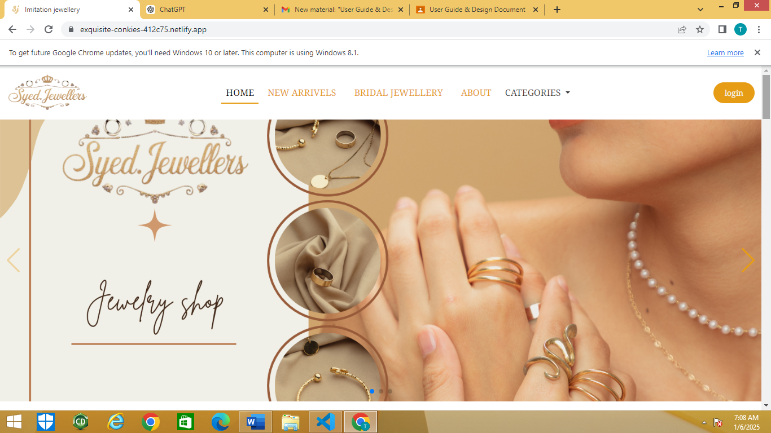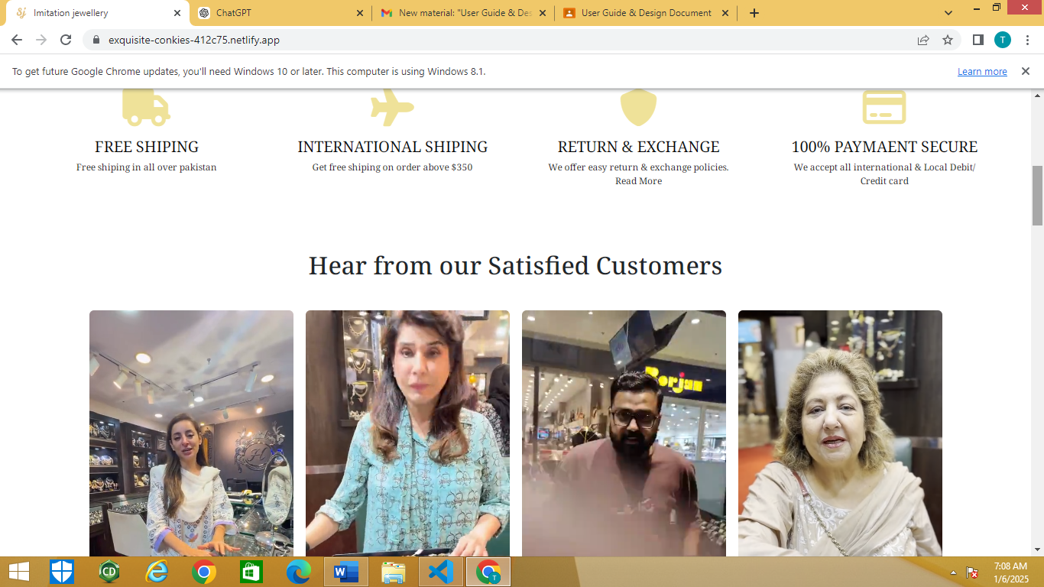

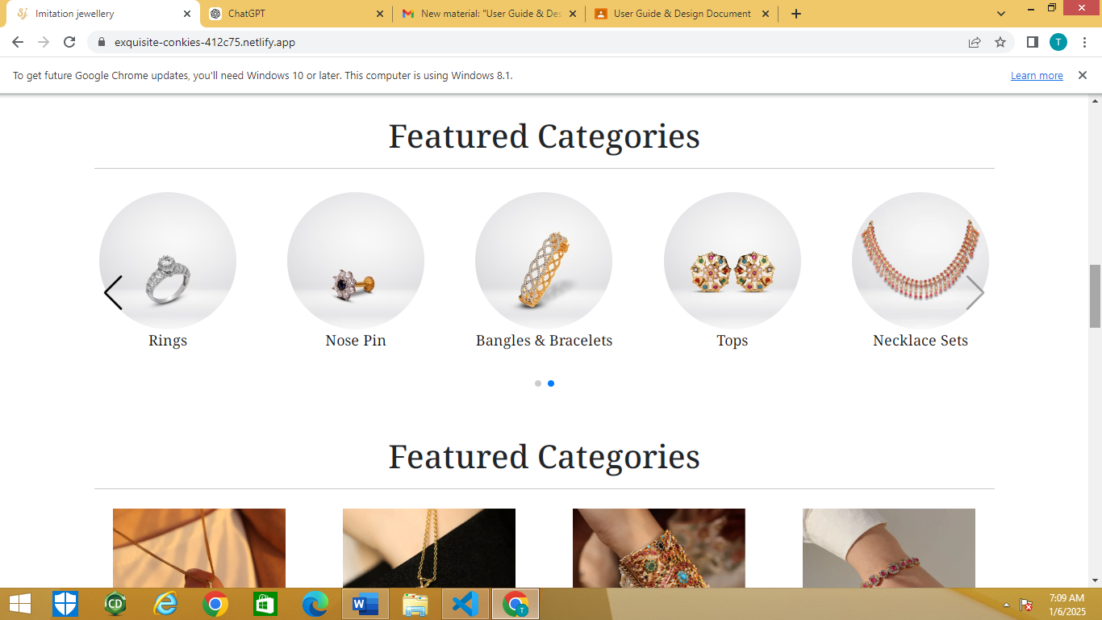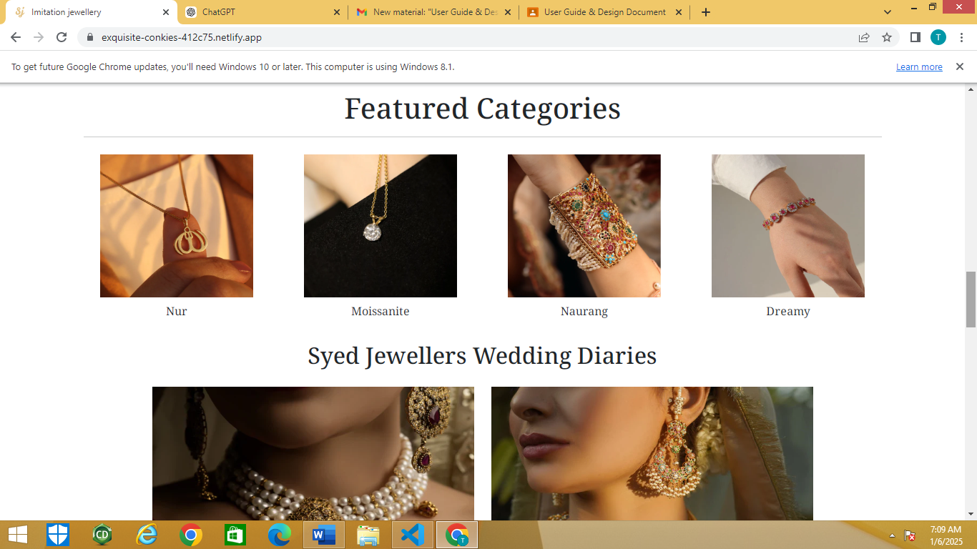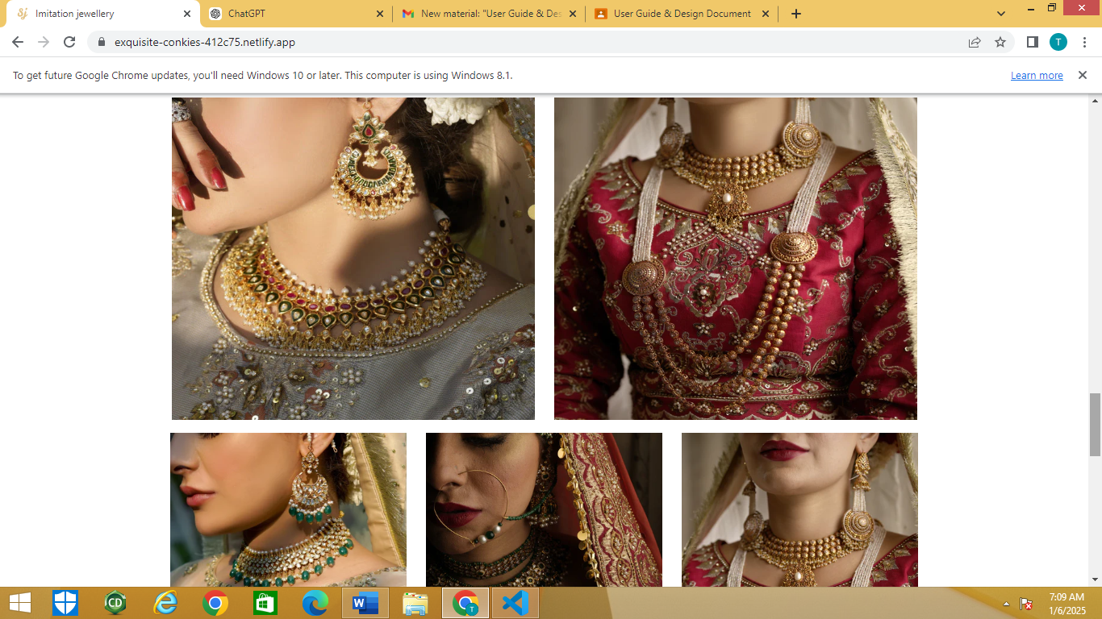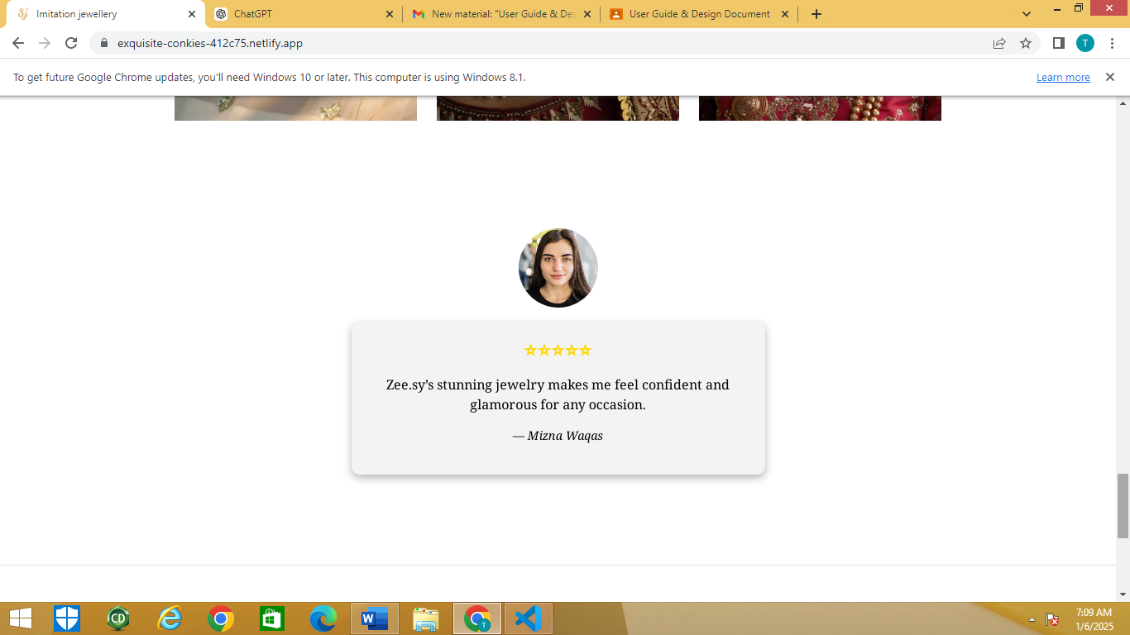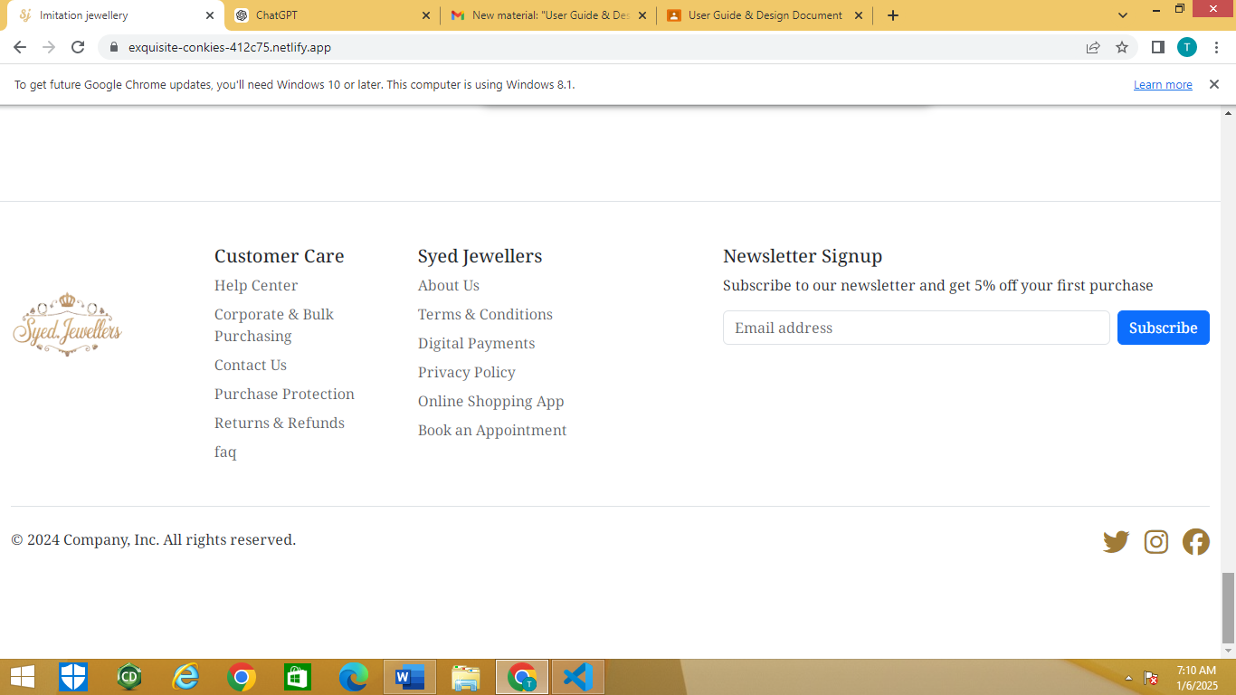

* **Flowchart Visual:** Detailed representation for website flow.

This document provides a detailed structure and flow for the Syed Jewellers website to guide development and ensure user-centric design.